**Assignment 6**

**Name – SURAJ KUMAR YADAV**

**ROLL NO. – 20220PHY014**

1. **Design a SR latch using NAND gates**

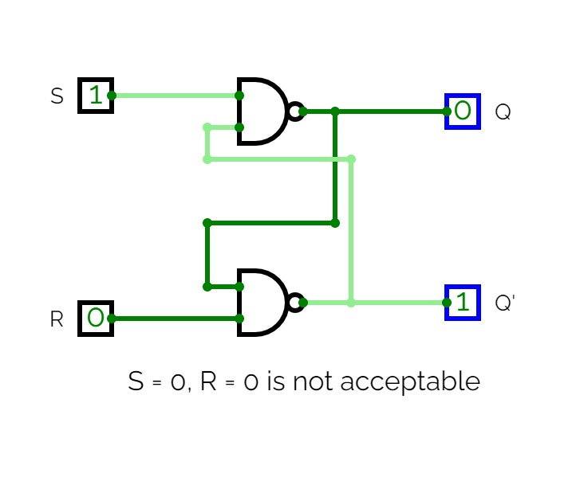

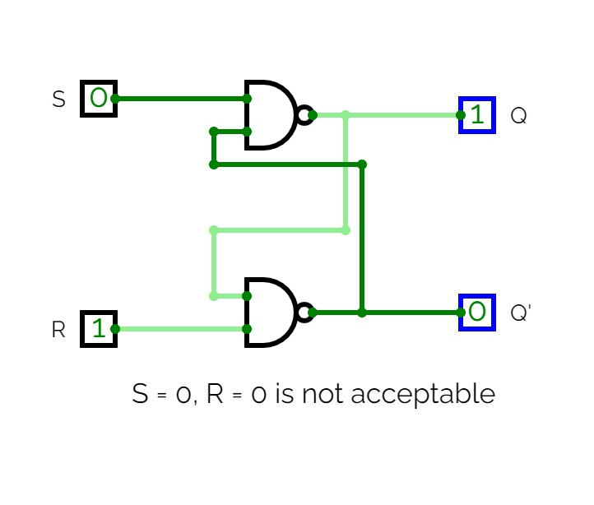

1. **Design a SR latch using NOR gates**

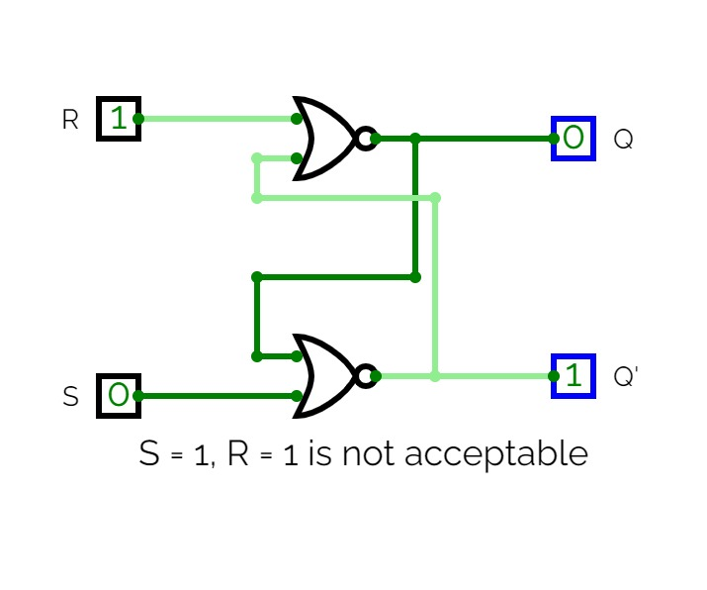

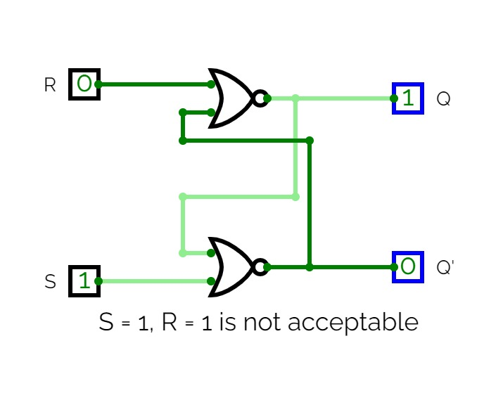

1. **Design SR latch with control input using NAND gates**

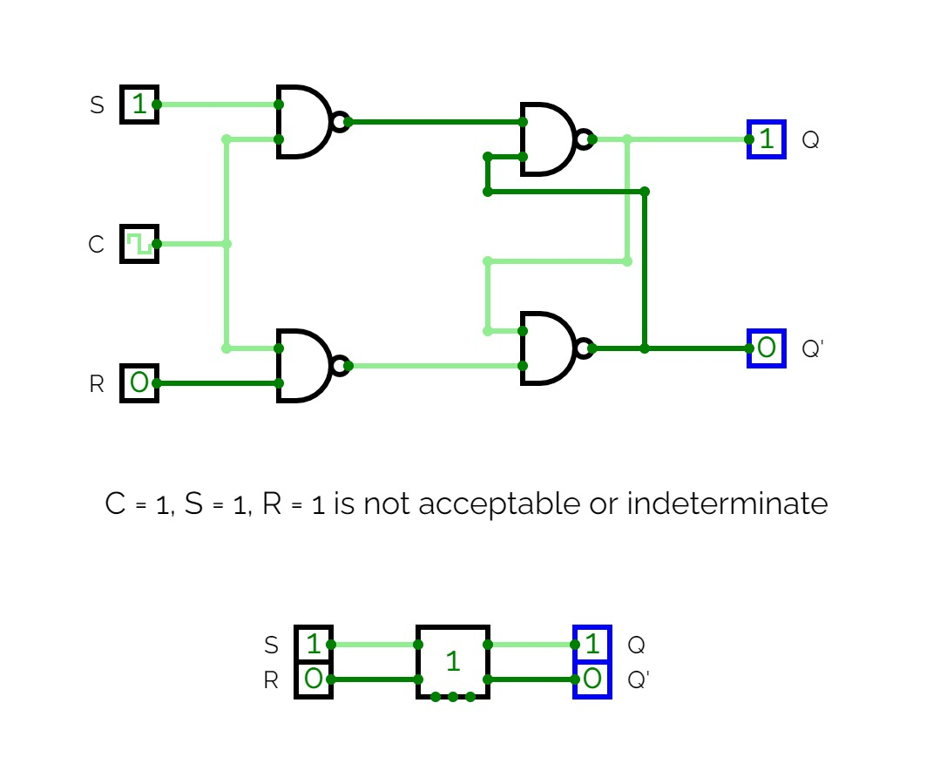

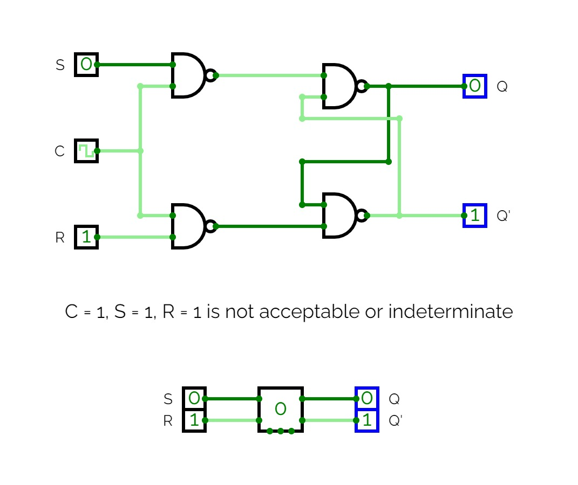

1. **Design D flip flop using NAND gate**

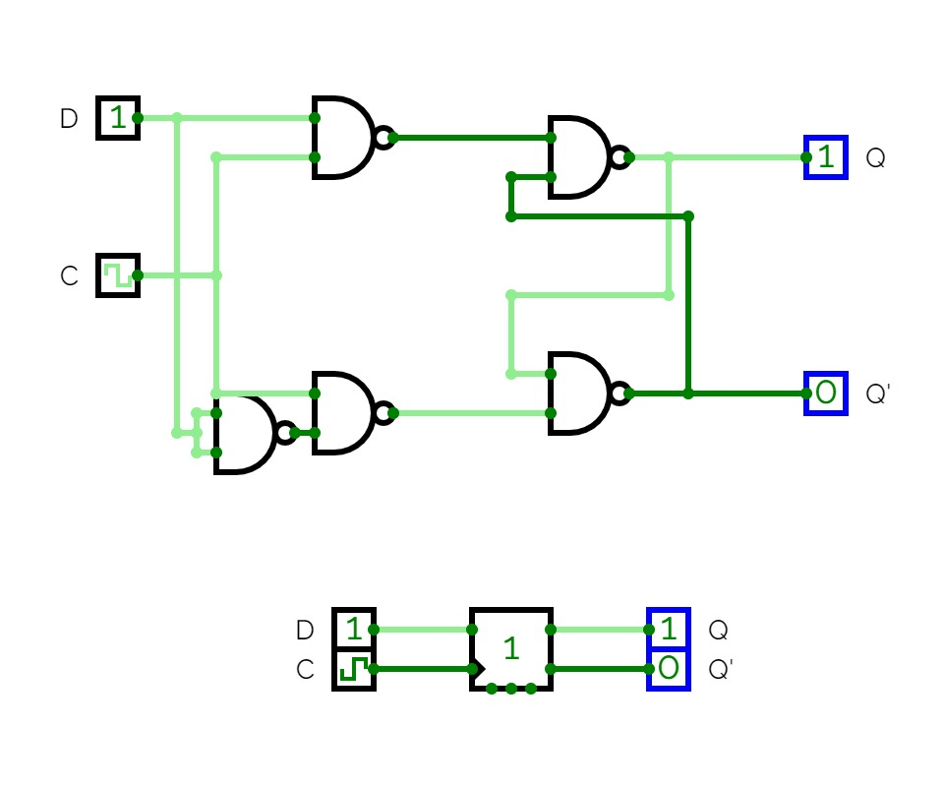

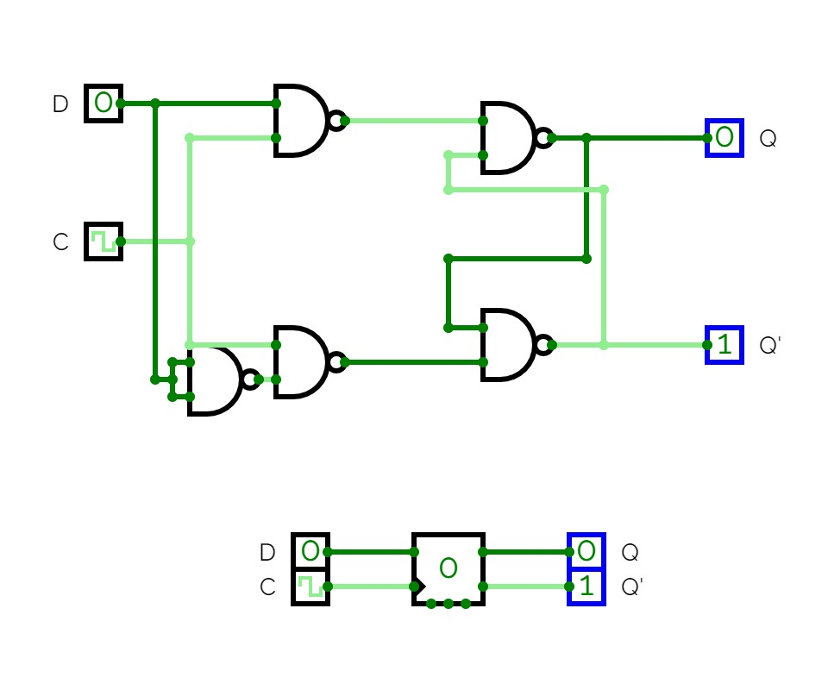

1. **Design JK flip flop using NAND gate and show the race around condition**

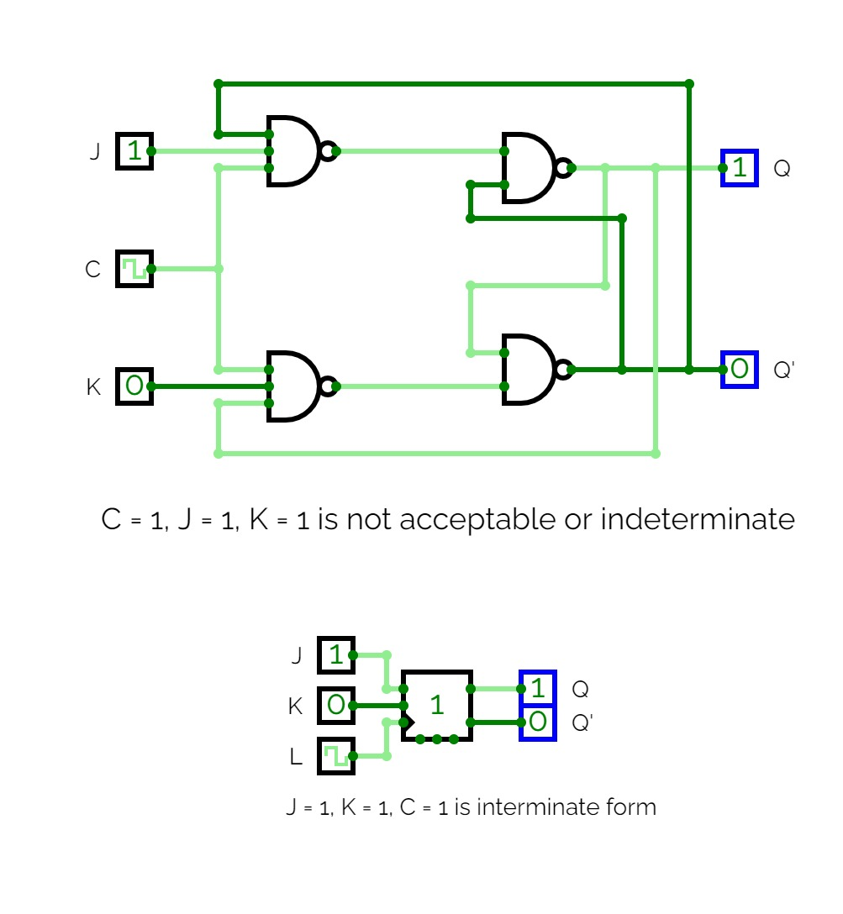

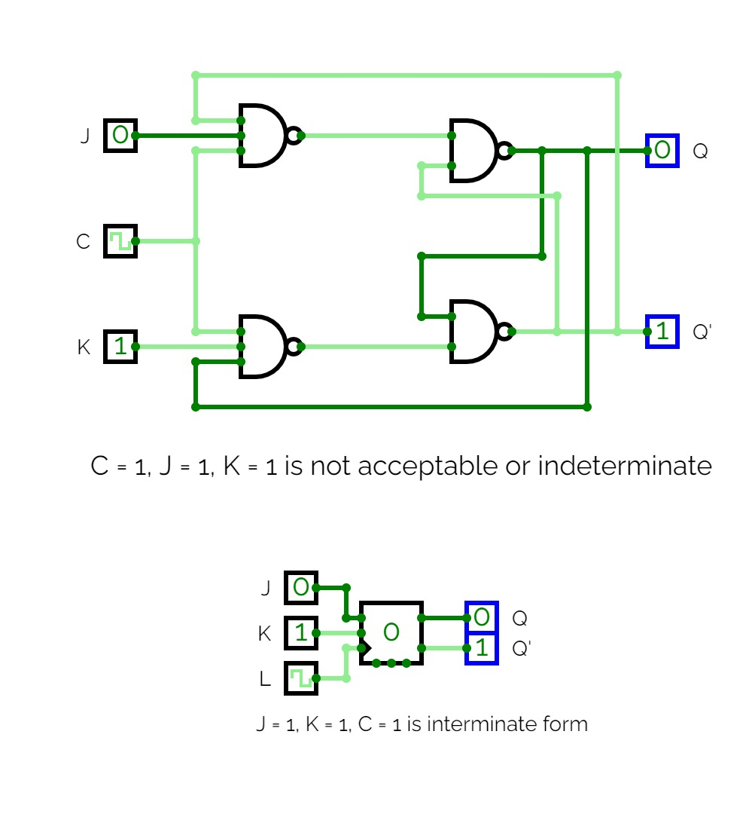

1. **Race around condition**

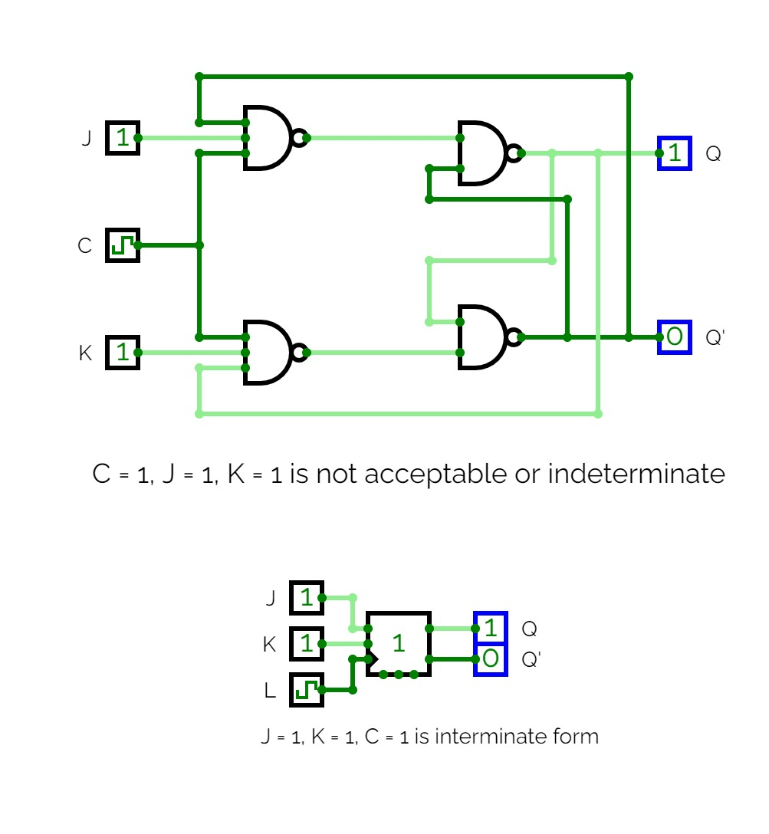

1. **Design JK flip flop using AND and NOR gates**

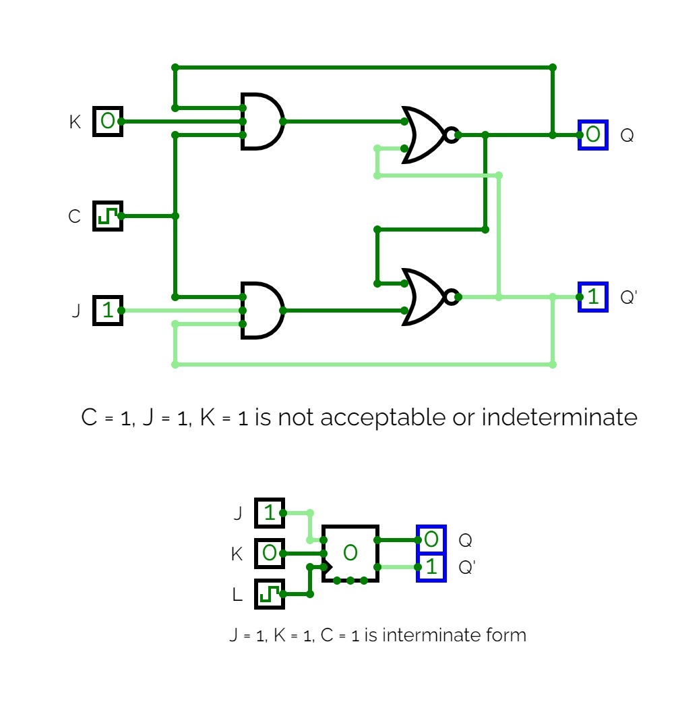

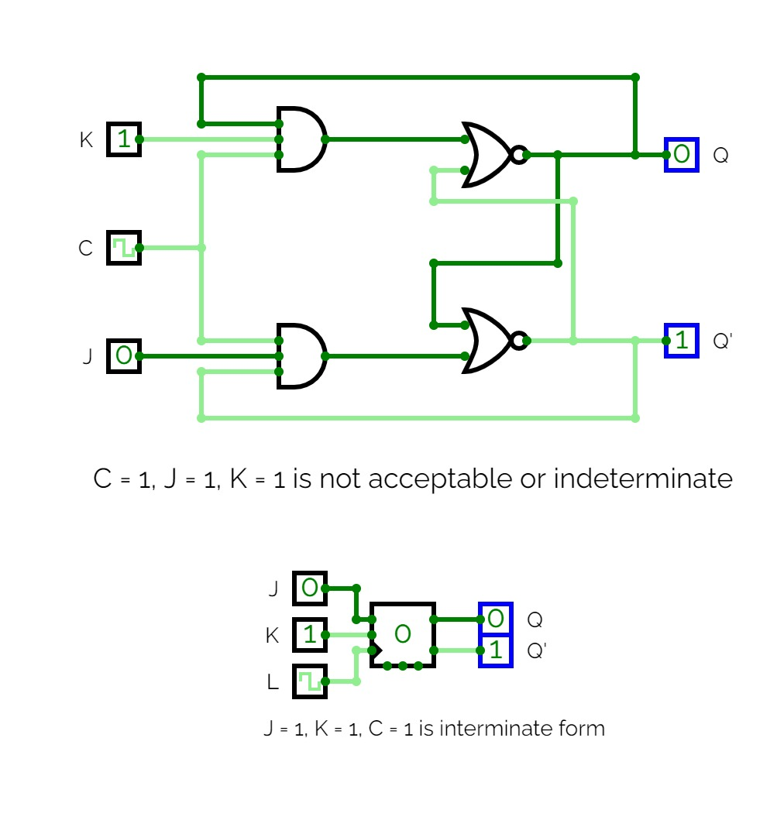

1. **Design T flip flop using NAND gates**

